**// Subroutine : UpdateButtonClick_DESIGN_SHIRT TYPE()**

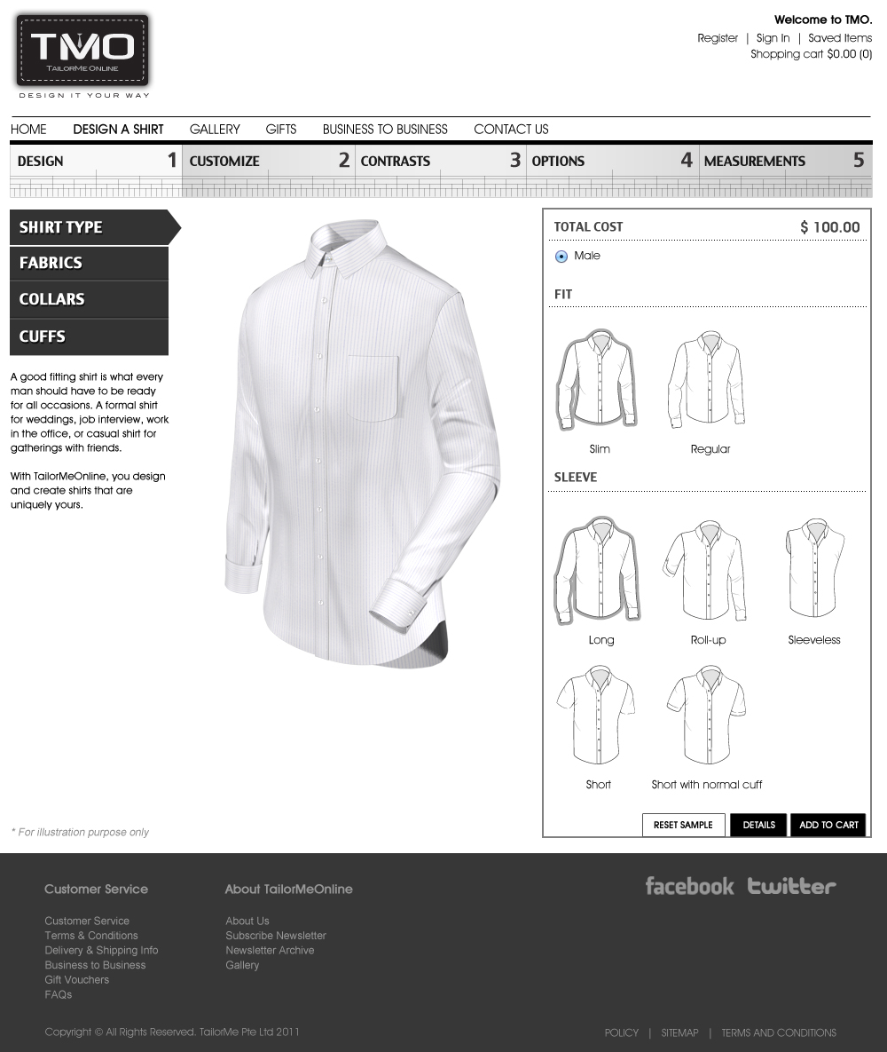

Clicking “Male” is disabled (on by default)

// -------------------------------------------------------------------- FIT

Upon clicking “Slim “:

ShirtLyr01[2] = “Torso-Slim-“;

ShirtLyr05[2] = “Slim”;

Call Subroutine : RefreshFilenames();

Call Subroutine : DisplayFullview();

Upon clicking “Regular “:

ShirtLyr01[2] = “Torso-Norm-“;

ShirtLyr05[2] = “Norm”;

Call Subroutine : RefreshFilenames();

Call Subroutine : DisplayFullview();

// -------------------------------------------------------------------- SLEEVE

Upon clicking “Long“:

ShirtLyr05[3] = “LongSleeve.”;

ShirtLyr05[5] = “Show”;

ShirtLyr12[5] = “Show”;

ShirtLyr13[5] = “Show”;

ShirtLyr14[5] = “Show”;

ShirtLyr15[5] = “Show”;

ShirtLyr16[5] = “Show”;

Call Subroutine : RefreshFilenames();

Call Subroutine : DisplayFullview();

Upon clicking “Roll-up“:

ShirtLyr05[3] = “RollupSleeve.”;

ShirtLyr05[5] = “Show”;

ShirtLyr12[5] = “Hide”;

ShirtLyr13[5] = “Hide”;

ShirtLyr14[5] = “Hide”;

ShirtLyr15[5] = “Hide”;

ShirtLyr16[5] = “Show”;

Call Subroutine : RefreshFilenames();

Call Subroutine : DisplayFullview();

Upon clicking “Sleeveless “:

ShirtLyr05[5] = “Hide”;

ShirtLyr12[5] = “Hide”;

ShirtLyr13[5] = “Hide”;

ShirtLyr14[5] = “Hide”;

ShirtLyr15[5] = “Hide”;

ShirtLyr16[5] = “Hide”;

Call Subroutine : RefreshFilenames();

Call Subroutine : DisplayFullview();

Upon clicking “Short “:

ShirtLyr05[3] = “ShortSleeve.”;

ShirtLyr05[5] = “Show”;

ShirtLyr12[5] = “Hide”;

ShirtLyr13[5] = “Hide”;

ShirtLyr14[5] = “Hide”;

ShirtLyr15[5] = “Hide”;

ShirtLyr16[5] = “Hide”;

Call Subroutine : RefreshFilenames();

Call Subroutine : DisplayFullview();

Upon clicking “Short with normal cuff“:

ShirtLyr05[3] = “NarrowCuffShortSleeve.”;

ShirtLyr05[5] = “Show”;

ShirtLyr12[5] = “Hide”;

ShirtLyr13[5] = “Hide”;

ShirtLyr14[5] = “Hide”;

ShirtLyr15[5] = “Hide”;

ShirtLyr16[5] = “Hide”;

Call Subroutine : RefreshFilenames();

Call Subroutine : DisplayFullview();

**// End of Subroutine : UpdateButtonClick_DESIGN A SHIRT_SHIRT TYPES()**